Heavy Weight #3

**Series #1 w/o strip; Series #2 w/ strip**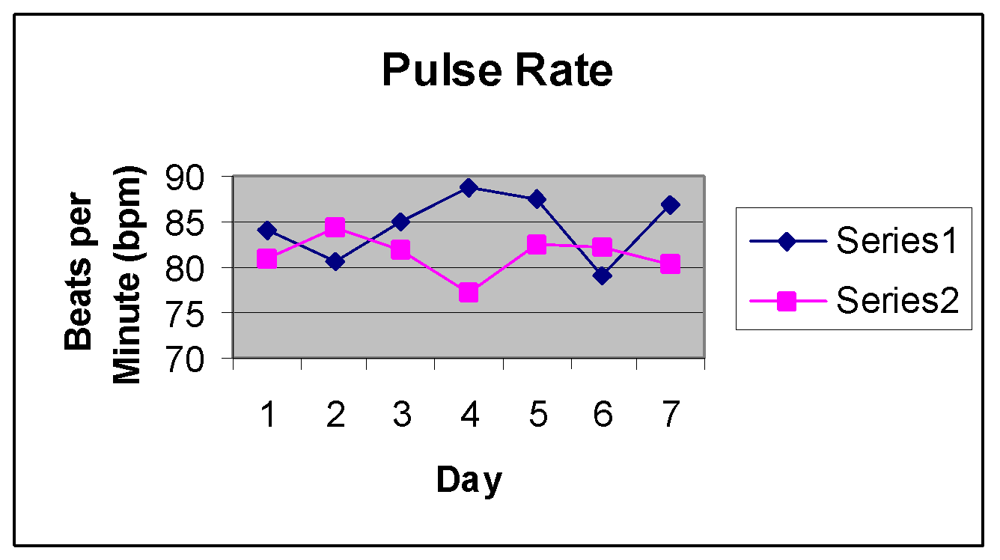

Series #1 mean: 84.5513 bpm; Series #2 mean: 81.5583 bpm

The Series #2 mean has less than a .001 probability of occurring by chance when compared to the Series #1 mean. This gives strong evidence that the nasal strip decreased the subject’s pulse rate.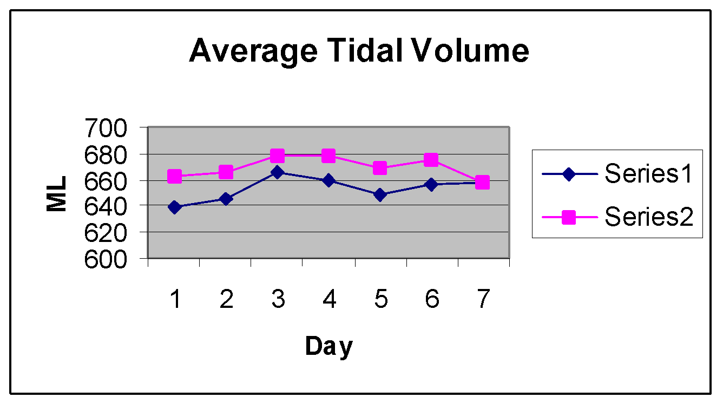

Series #1 mean: 653.0578 ml; Series #2 mean: 669.4398 ml

The Series #2 mean has less than a .01 probability of occurring by chance when compared to the mean of Series #1. This gives strong evidence that the nasal strip increased the subject’s tidal volume.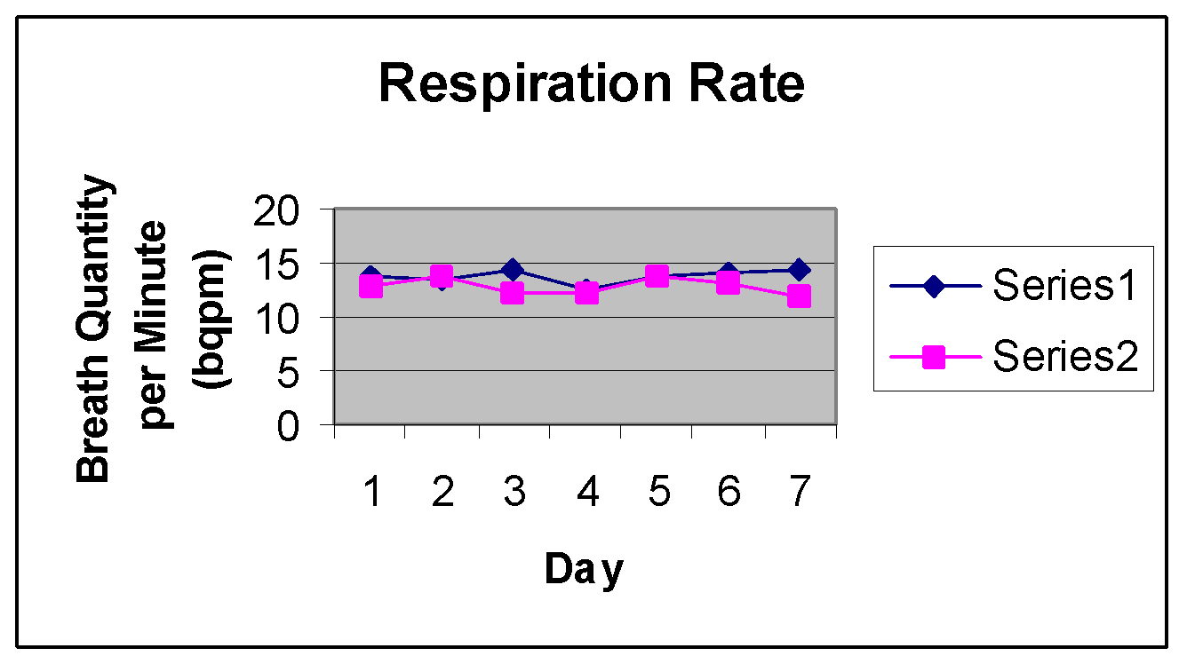

Series #1 mean: 13.732 bqpm; Series #2 mean : 12.827 bqpm

The Series #2 mean has a .0473 probability of occurring by chance when compared to the mean in Series #1. This gives strong evidence that the nasal strip decreased the subject’s respiratory rate.

Series #1 mean : 269,033.69 ml; Series #2 mean: 257,602.179 ml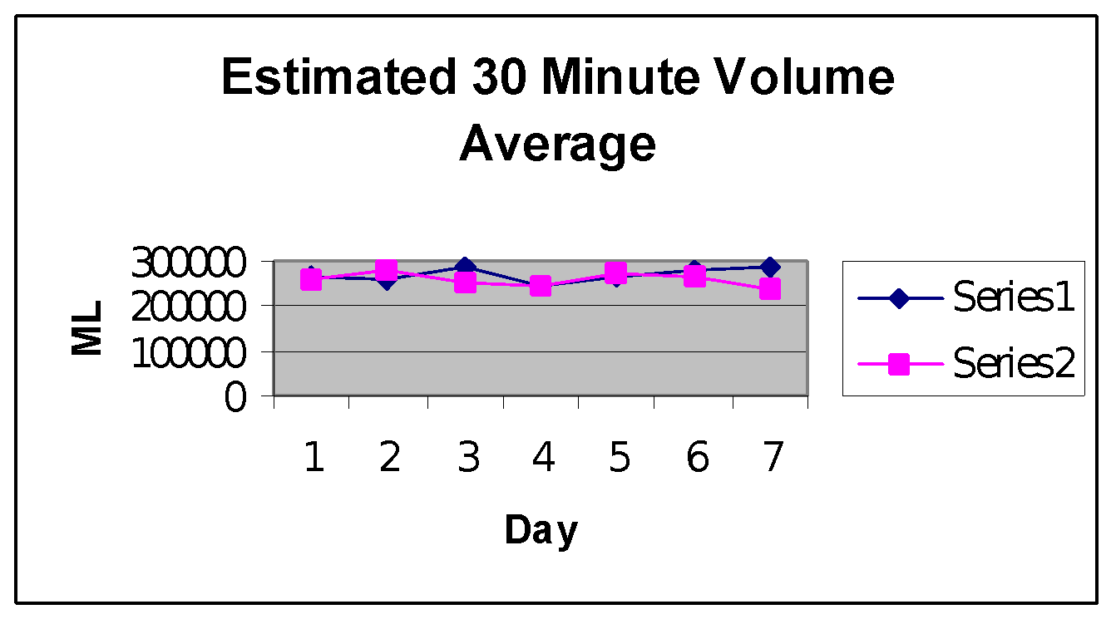

The Series #2 mean has a probability of .3957 of occurring by chance when compared to the Series #1 mean. This gives weak evidence that the nasal strip either increased or decreased the subject’s 30 minute volume.